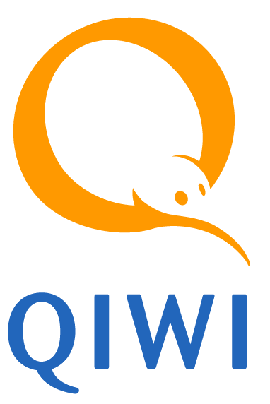

QIWI Announces First Quarter 2016 Financial Results

First Quarter Total Adjusted Net Revenue Decreased 0.2% to RUB 2,509 Million and Adjusted Net Profit Increases 10% to RUB 1,233 Million or RUB 20.41 per diluted share
QIWI reiterates 2016 Guidance
Board of Directors Approves Dividend of 22 cents per share

NICOSIA, CYPRUS – May 18, 2016 – QIWI plc, (NASDAQ: QIWI) (MOEX: QIWI) (“QIWI” or the “Company”) today announced results for the first quarter ended March 31, 2016.

First Quarter 2016 Operating and Financial Highlights

- Total Adjusted Net Revenue decreased 0.2% to RUB 2,509 million ($37.1 million)
- Adjusted EBITDA decreased 8% to RUB 1,466 million ($21.7 million)
- Adjusted Net Profit increased 10% to RUB 1,233 million ($18.2 million), or RUB 20.41 per diluted share
- Total payment volume increased 25% to RUB 198.1 billion ($2.9 billion)

“In the first quarter we continued to feel pressure from the macroeconomic slowdown in Russia and lower demand for money remittance services due to shifting migration trends,” said Sergey Solonin, QIWI’s chief executive officer. “Notwithstanding the challenging market, we managed to increase our payment adjusted net revenue as well as adjusted net profit. Although we believe that 2016 will be challenging, we are focusing on increasing the loyalty of both our consumers and merchants by offering them a broader scope of services and gaining market share in our key verticals.”

First Quarter 2016 Results

Revenues: Total Adjusted Net Revenue for the quarter ended March 31, 2016 was RUB 2,509 million ($37.1 million), a decrease of 0.2% compared with RUB 2,515 million in the prior year.

Payment Adjusted Net Revenue was RUB 2,004 million ($29.6 million), an increase of 9% compared with RUB 1,840 million in the prior year. Payment Adjusted Net Revenue growth was predominantly driven by an increase in payment volume across most verticals except Telecom, especially the Money Remittances and Financial Services market verticals, that was in turn partially offset by the declining net revenue yields primarily as a result of the acquisition and consolidation of Contact and Rapida which operate on significantly lower net revenue yields than legacy QIWI business.

Other Adjusted Net Revenue, which is principally composed of revenue from inactivity fees, interest revenue and gain from currency swaps and overdrafts provided to agents, revenue from rent of space for kiosks, cash and settlement services and advertising, was RUB 505 million ($7.5 million), an decrease of 25% compared with RUB 675 million in the prior year. The decline in the first quarter was mainly due to decrease in cash and settlement services, interest revenue on overdrafts provided to agents, revenue from sales of kiosks and rent of space of kiosks partially offset by increase in inactivity fees. Inactivity fees for the first quarter ended March 31, 2016 were RUB 334 million ($4.9 million) compared with RUB 187 million in the prior year as a result of changes to the write-off policy as well as consolidation of Contact and Rapida business. Other Adjusted Net Revenue excluding revenue from fees for inactive accounts decreased 65% compared with the same period in the prior year.

Total Adjusted Net Revenue excluding revenue from fees for inactive accounts decreased 7% compared with the same period in the prior year.

Adjusted EBITDA: For the quarter ended March 31, 2016, Adjusted EBITDA was RUB 1,466 million ($21.7 million), an decrease of 8% compared with RUB 1,600 million in the prior year. Adjusted EBITDA decline was largely due to bad debt expense that amounted to RUB 12 million in the first quarter 2016 as opposed to RUB 67 million of bad debt recovery in the first quarter of 2015. Adjusted EBITDA margin (Adjusted EBITDA as a percentage of Total Adjusted Net Revenue) was 58.4% compared with 63.6% in the prior year. Adjusted EBITDA excluding inactivity fees was RUB 1,132 million ($16.7 million), a decrease of 20% compared with RUB 1,413 million in the prior year. Adjusted EBITDA margin excluding inactivity fees was 52.1% compared with 60.7% in the prior year.

Adjusted Net Profit: For the quarter ended March 31, 2016, Adjusted Net Profit was RUB 1,233 million ($18.2 million), an increase of 10% compared with RUB 1,117 million in the prior year. The increase in Adjusted Net Profit was primarily driven by the same factors impacting Adjusted EBITDA offset by a foreign exchange gain generated in the first quarter 2016 as compared to foreign exchange loss¹ in the first quarter of 2015. Adjusted Net Profit excluding inactivity fees (net of tax) did not change compared with the prior year.

Other Operating Data: For the quarter ended March 31, 2016, total payment volume was RUB 198.1 billion ($2.9 billion), an increase of 25% compared with RUB 158.4 billion in the prior year. Payment volume increased across most verticals driven largely by Contact and Rapida businesses consolidation. Payment average net revenue yield was 1.01%, a decrease of 15 bps compared with 1.16% in the prior year primarily due to the consolidation of lower yielding Contact and Rapida businesses.

Total average Net Revenue Yield was 1.27%, a decrease of 32 bps as compared with 1.59% in the prior year. Total average Net Revenue Yield excluding the effect of inactivity fees was 1.10%, a decrease of 37 bps as compared with the same period in the prior year.

The number of active kiosks and terminals was 167,399 including Contact and Rapida physical points of service, a decrease of 6% compared with the prior year, primarily resulting from enhanced controls that the Central Bank of Russia has implemented over the agents. The number of active Visa Qiwi Wallet accounts was 16.1 million as of the end first quarter of 2016, a decrease of 1.2 million, or 7%, as compared with 17.3 million in the first quarter of 2015. The decrease was driven mainly by the lower marketing spend in the end of 2015 and beginning of 2016 as compared to a year ago, as well as the decrease in the kiosk network in Russia in the second half of 2015 and overall economic downturn affecting consumer activity.

Recent Developments

Dividend: Following the determination of first quarter 2016 financial results our Board of Directors approved a dividend of USD 22 cents per share. The dividend record date is May 26, 2016, and the Company intends to pay the dividend on May 27, 2016. The holders of ADSs will receive the dividend shortly thereafter.
We continue to pursue certain M&A targets, thus our view on dividends distribution throughout 2016 is subject to change.

Impact of Contact and Rapida: Starting June 1st 2015 we consolidate financial results of Contact and Rapida in our financial statements which are presented below. Contact and Rapida have become a strong addition to the core business of QIWI contributing to Money Remittance, Financial Services and E-commerce market verticals as well as increasing our share of the Russian money remittance market, broadening our merchant relationships and consumer base and strengthening our team. The integration is going in accordance with the plan.

Regulation by the Central Bank of Russia: Our kiosk network in Russia was affected by the enhanced controls that the Central Bank of Russia has implemented to ensure compliance by the agents with legislation that requires them to remit their proceeds to special accounts, as disclosed in our Form 6-K filed on November 2, 2015.

Although through reducing the size of our network, this adversely affects the availability and convenience of our services to consumers in the short-term, we continue to believe that increased transparency in the kiosk market will ultimately allow us to improve our market share and strengthen our competitive advantages.

2016 Guidance

QIWI reiterates its guidance in respect of 2016 outlook:

- Total Adjusted Net Revenue is expected to increase by 5% to 8% over 2015
- Adjusted Net Profit is expected to increase by 7% to 12% over 2015

The overall macroeconomic conditions continue to adversely affect the purchasing power of Russian population as decreasing real wages put pressure on the disposable income. This in turn leads to the overall decrease in consumer spending and consequently our payment volumes.
We have also noted negative trends in Money Remittance market due to shifting migration trends. We anticipate that downward trends and weaker demand for money remittance services can negatively affect our volumes and revenues in this category.

Earnings Conference Call and Audio Webcast

QIWI will host a conference call to discuss first quarter 2016 financial results today at 8:30 a.m. ET. Hosting the call will be Sergey Solonin, chief executive officer, and Alexander Karavaev, chief financial officer. The conference call can be accessed live over the phone by dialing +1 (877) 407-3982 or for international callers by dialing +1 (201) 493-6780. A replay will be available at 11:30 a.m. ET and can be accessed by dialing +1 (877) 870-5176 or +1 (858) 384-5517 for international callers; the pin number is 13637012. The replay will be available until Wednesday, May 25, 2016. The call will be webcast live from the Company’s website at https://www.qiwi.ru under the Corporate Investor Relations section or directly at http://investor.qiwi.com/.

About QIWI plc.

QIWI is a leading provider of next generation payment services in Russia and the CIS. It has an integrated proprietary network that enables payment services across physical, online and mobile channels. It has deployed over 16.1 million virtual wallets, over 167,000 kiosks and terminals, and enabled merchants to accept over RUB 66 billion cash and electronic payments monthly from over 62 million consumers using its network at least once a month. QIWI’s consumers can use cash, stored value and other electronic payment methods to order and pay for goods and services across physical or online environments interchangeably.

Forward-Looking Statements

This press release includes “forward-looking statements” within the meaning of, and subject to the protection of, the Private Securities Litigation Reform Act of 1995, including, without limitation, statements regarding expected total adjusted net revenue, adjusted net profit and net revenue yield, dividend payments, payment volume growth, and growth of physical and virtual distribution channels. Such forward-looking statements involve known and unknown risks, uncertainties, and other factors that may cause the actual results, performance or achievements of QIWI plc. to be materially different from future results, performance or achievements expressed or implied by such forward-looking statements. Various factors that could cause actual future results and other future events to differ materially from those estimated by management include, but are not limited to, competition, a decline in average net revenue yield, fees levied on QIWI’s consumers, regulation, QIWI’s ability to grow physical and virtual distribution channels, QIWI’s ability to expand geographically and other risks identified under the Caption “Risk Factors” in QIWI’s Annual Report on Form 20-F and in other reports QIWI files with the U.S. Securities and Exchange Commission. QIWI undertakes no obligation to revise any forward-looking statements or to report future events that may affect such forward-looking statements unless QIWI is required to do so by law.

Contact

Varvara Kiseleva
Investor Relations
+357.25028091
ir@qiwi.com

QIWI plc.
Consolidated Statement of Financial Position
(in million)

- Calculated using a ruble to U.S. dollar exchange rate of RUB 67.608 to U.S. $1.00, which was the official exchange rate quoted by the Central Bank of the Russian Federation as of March 31, 2016.

QIWI plc.
Consolidated Statement of Comprehensive Income
(in millions, except per share data)

- Calculated using a ruble to U.S. dollar exchange rate of RUB 67.608 to U.S. $1.00, which was the official exchange rate quoted by the Central Bank of the Russian Federation as of March 31, 2016.

QIWI plc.
Consolidated Statement of Cash Flows
(in million)

- The amounts shown here differ immaterially from the financial statements for the year ended March 31, 2015 and reflect insignificant adjustments made to prior period for cash in held-for-sale assets.
- Calculated using a ruble to U.S. dollar exchange rate of RUB 67.608 to U.S. $1.00, which was the official exchange rate quoted by the Central Bank of the Russian Federation as of March 31, 2016.

Non-IFRS Financial Measures and Supplemental Financial Information

This release presents Total Adjusted Net Revenue, Payment Adjusted Net Revenue, Other Adjusted Net Revenue, Adjusted EBITDA, Adjusted EBITDA margin, Adjusted Net Profit and Adjusted Net Profit per share, which are non-IFRS financial measures. You should not consider these non-IFRS financial measures as substitutes for or superior to revenue, in the case of Total Adjusted Net Revenue, Payment Adjusted Net Revenue and Other Adjusted Net Revenue; Net Profit, in the case of Adjusted EBITDA; and Adjusted Net Profit, or earnings per share, in the case of Adjusted Net Profit per share, each prepared in accordance with IFRS. Furthermore, because these non-IFRS financial measures are not determined in accordance with IFRS, they are susceptible to varying calculations and may not be comparable to other similarly titled measures presented by other companies. QIWI encourages investors and others to review our financial information in its entirety and not rely on a single financial measure. For more information regarding Total Adjusted Net Revenue, Payment Adjusted Net Revenue, Other Adjusted Net Revenue, Adjusted EBITDA, Adjusted EBITDA margin, Adjusted Net Profit, and Adjusted Net Profit per share, including a quantitative reconciliation of Total Adjusted Net Revenue, Payment Adjusted Net Revenue, Other Adjusted Net Revenue, Adjusted EBITDA and Adjusted Net Profit to the most directly comparable IFRS financial performance measure, which is revenue in the case of Total Adjusted Net Revenue, payment revenue in the case of Payment Adjusted Net Revenue, other revenue in the case of Other Adjusted Net Revenue and net profit in the case of Adjusted EBITDA and Adjusted Net Profit, see Reconciliation of IFRS to Non-IFRS Operating Results in this earnings release.

Payment Adjusted Net Revenue is the Adjusted Net Revenue consisting of the merchant and consumer fees collected for the payment transactions. E-commerce payment adjusted net revenue consists of fees charged to customers and merchants that buy and sell products and services online, including online games, social networks, online stores, game developers, software producers, coupon websites, tickets and numerous other merchants. Financial Services payment adjusted net revenue primarily consists of fees charged for payments accepted on behalf of our bank partners and microfinance companies. Money Remittances payment adjusted net revenue primarily consists of fees charged for transferring funds via money remittance companies. Telecom payment adjusted net revenue primarily consists of fees charged for payments to MNOs, internet services providers and pay television providers. Other payment adjusted net revenue consists of consumer and merchant fees charged for a variety of payments including multi-level-marketing, utility bills, government payments, education services and many others. Other Adjusted Net Revenue primarily consists of revenue from inactivity fees, interest revenue and gain from currency swaps and overdrafts provided to agents, revenue from rent of space for kiosks and sale of kiosks, cash and settlement services and advertising.

QIWI plc.
Reconciliation of IFRS to Non-IFRS Operating Results
(in millions, except per share data)

- Calculated using a ruble to U.S. dollar exchange rate of RUB 67.608 to U.S. $1.00, which was the official exchange rate quoted by the Central Bank of the Russian Federation as of March 31, 2016.
- Payment revenue primarily consists of the merchant and consumer fees charged for the payment transactions.
- Cost of payment revenue (exclusive of depreciation and amortization) primarily consists of transaction costs to acquire payments from our customers payable to agents, mobile operators, international payment systems and other parties.
- The Company does not record the compensation to employees and related taxes within cost of revenue separately for payment revenue and other revenue, therefore it has been allocated between payment revenue and other revenue in proportion to the relevant revenue amounts for the purposes of the reconciliation presented above.
- Other Revenue primarily consists of revenue from inactivity fees, interest revenue and gain from currency swaps and overdrafts provided to agents, revenue from rent of space for kiosks and sale of kiosks, cash and settlement services and advertising..
- Cost of other revenue (exclusive of depreciation and amortization) primarily consists of direct costs associated with other revenue and other costs, including but not limited to: compensation to employees and related taxes allocated to other revenue, costs of call-centers and advertising commissions.
- Amortization of fair value adjustments includes the effect of the acquisition of control in Contact and Rapida.
- The Forex loss/(gain) on SPO funds as presented in the reconciliation of Net Profit to Adjusted Net Profit differs from the Foreign exchange loss/(gain), net in the reconciliation of Net Profit to Adjusted EBITDA as the latter includes all the foreign exchange losses/(gains) for the period, while the former only include the foreign exchange loss/(gain) on the US dollar amount, which we received at SPO.

QIWI plc.
Other Operating Data

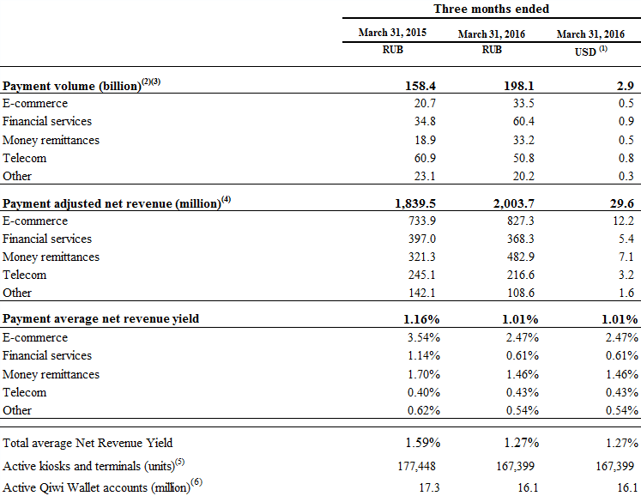

- Calculated using a ruble to U.S. dollar exchange rate of RUB 67.608 to U.S. $1.00, which was the official exchange rate quoted by the Central Bank of the Russian Federation as of March 31, 2016.
- Payment volume by market verticals and consolidated payment volume consist of the amounts paid by our customers to merchants included in each of those market verticals less intra-group eliminations. The methodology of payment volumes allocation between different market verticals in QIWI’s international operations (including Kazakhstan) may differ from the methodology used by QIWI’s Russian operations. We therefore retain the right to restate the presented volumes, net revenues and net revenue yields data in case the methodology of QIWI’s international operations will be brought in conformity with the methodology of QIWI’s Russian operations.
- Payment volume by market verticals and consolidated payment volume consist of the amounts paid by our customers to merchants included in each of those market verticals less intra-group eliminations. The methodology of payment volumes allocation between different market verticals in Contact and Rapida may differ from the methodology used by QIWI. We therefore retain the right to restate the presented volumes, net revenues and net revenue yields data in case the methodology of Contact and Rapida will be brought in conformity with the methodology used by QIWI.
- Payment Adjusted Net Revenue is calculated as the difference between Payment Revenue and Cost of payment revenue (excluding D&A) plus compensation to employees and related taxes allocated to payment revenue. Payment Revenue primarily consists of merchant and consumer fees. Cost of payment revenue primarily consist of commission to agents.
- We measure the numbers of our kiosks and terminals on a daily basis, with only those kiosks and terminals being taken into calculation through which at least one payment has been processed during the day, which we refer to as active kiosks and terminals. The period end numbers of our kiosks and terminals are calculated as an average of the amount of active kiosks and terminals for the last 30 days of the respective reporting period.
- Active Visa Qiwi Wallet accounts calculated on a yearly basis, i.e. an active account is an account that had at least one transaction within the last 12 months from the reporting date.

Foreign exchange gain/loss is calculated as total foreign exchange gain/loss, net recognized in the statement of comprehensive income excluding the effect of foreign exchange gain/loss on June 2014 offering proceed
Guidance is provided in Russian rubles

